**Sprint** 2 **-** Accuracy **Design Document**

April 11, **20**

**Table of Contents**

**1.** **EXECUTIVE SUMMARY 3**

1.1 Project Overview 3

1.2 Purpose and Scope of this Specification 3

**2.** **PRODUCT/SERVICE DESCRIPTION 3**

2.1 Product Context 3

2.2 User Characteristics 3

2.3 Assumptions 3

2.4 Constraints 3

2.5 Dependencies 4

**3.** **REQUIREMENTS 4**

3.1 Functional Requirements 5

3.2 Security 5

*3.2.1* *Protection 5*

*3.2.2* *Authorization and Authentication* 5

3.3 Portability 5

**4.** **REQUIREMENTS CONFIRMATION/STAKEHOLDER SIGN-OFF** 5

**5.** **SYSTEM DESIGN 6**

5.1 Algorithm 6

5.2 System Flow 7

5.3 Software 8

5.4 Hardware 9

5.5 Test Plan 9

5.6 Task List/Gantt Chart 10

5.7 Staffing Plan 10

# Executive Summary

## ***Project Overview***

This document includes some of the documents, files, and other information required for the accuracy-sprint portion (Sprint 2) of the CS104 Robotics Triathlon as outlined in the CS 104-01 Class syllabus for Spring 2022. The robot must complete a figure-eight course on the floor of room HH-208. A video will be taken to show the robot completing its task.

## ***Purpose and Scope of this Specification***

Describe the purpose of this specification and its intended audience. Include a description of what is within the scope and what is outside of the scope of these specifications. For example:

**In scope**

* This part includes the testing for the Accuracy (figure-eight) course only, this is further explained in section 2.1

**Out of Scope**

* This part does not involve the testing for Agility and Endurance

# Product/Service Description

## ***Product Context***

This project is part 2 of the robotics triathlon containing three different sprints. The three sprints are Endurance, Accuracy, and Agility. This part contains the Accuracy section of the project. Each section will be presented via video format.

## ***User Characteristics***

Our group contains three students testing, recording, and fixing the robot when it needs to be. A final video is to be presented at the end of the project. Our group members have little experience having used this type of robot only in the first sprint, but we have some experience working with the block code.

## ***Assumptions***

We are using a robot called the SPRK+ and we will be using Sphero Edu for the programming and block code. This app can be used on our phones or laptops, but we programmed the robot using our laptops. The course we are following is inside room HH-208. We will be using an iPhone 13 when filming the robot.

## ***Constraints***

Some constraints for this project included the room and course not always being available to use, this limited the time we had to work together to test and make changes to the robot. Other constraints included finding the right time for us all to meet up and work together on the project. Some members had busy schedules which caused major time constraints. Some other problems included other groups using the room at the same time as us, which made it harder when both robots were on the same course.

## ***Dependencies***

Some dependencies include the robot being charged in order for it to work. The robot to be up to date in order for it to follow the block code successfully. Other dependencies are making sure the robot can accurately repeat coded loops so it may repeat the figure eight course with precision and accuracy.

# Requirements

## ***Functional Requirements***

| **Req#** | **Requirement** | **Comments** | **Priority** | **Date Rvwd** | **SME Reviewed / Approved** |
| --- | --- | --- | --- | --- | --- |
| ENDUR_01 | Robot must star tin the middle of the figure 8 |  | 1 | 4/7 | 4/7 |
| ENDUR_02 | Robot must complete a circle |  | 1 | 4/7 | 3/7 |
| ENDUR_04 | Robo must stay on the tape |  | 1 | 4/7 | 4/7 |
| ENDUR_05 | Robot must complete another circle in opposite direction | This was the hardest part it would stray every time | 1 | 4/7 | 4/7 |
| ENDUR_06 | Robot must put both circles together |  | 1 | 4/7 | 4/7 |
| ENDUR_07 | Robot must complete 5 cycles of the figure 8 | After the first cycle it would start to move off the tape, we had to fix this problem | 1 | 4/7 | 4/7 |
| ENDUR_08 | Robot will speak “I am the Winner” upon completion |  | 1 | 4/7 | 4/7 |
| ENDUR_09 | Robot will flash multi colored lights |  | 1 | 4/7 | 4/7 |

## ***Security***

### **Protection**

The key for the protection of the software and hardware was with the group's overall accountability. The robot itself was always with one of the group members at all times and each time it was used was with all members present. In addition, each time the software was manipulated and changed, the progress was saved and logged.

### **Authorization and Authentication**

Pubcookie will be used for authorization of each user trying to use the software. Users simply trying to use the software for their own personal trials will be authenticated as “guest” and the group members associated with the overall project will be authenticated as “Accuracy.”

## ***Portability***

Due to the fact that the Sphero Edu program is portable on most systems, the code used in this project can be easily used on many different devices and networks. All any user must do is download the appropriate version of Sphero that corresponds to their operating system. The only portion of the project that is not portable is the course itself.

# Requirements Confirmation/Stakeholder sign-off

| **Meeting Date** | **Attendees (name and role)** | **Comments** |
| --- | --- | --- |
| 04/04/22 | Chalen, Jack, Dennis | Met to test the robot |
| 04/07/22 | Chalen, Jack, Dennis | Met to test the robot |

# System Design

## ***Algorithm***

1. Start
2. Set laps to 0
3. Set heading to 0
4. Set speed to 50
5. Add 20 to heading
6. If heading is less than 360 repeat step 5
7. set heading to 0
8. Subtract 20 from heading
9. If heading is greater than 360 repeat step 8
10. Add 1 to laps
11. If laps is less than 5, repeat steps 5 - 10
12. Set speed to 0
13. speak “I am the Winner”
14. Set StrobeCount to 0
15. Set strobe to green for 0.2 seconds
16. Set strobe to blue for 0.2 seconds
17. Set strobe to gold for 0.2 seconds
18. Set strobe to red for 0.2 seconds
19. Set strobe to white for 0.2 seconds
20. Add 1 to strobe count
21. If strobe count is less than 5 repeat steps 15-20
22. End program

## ***System Flow***

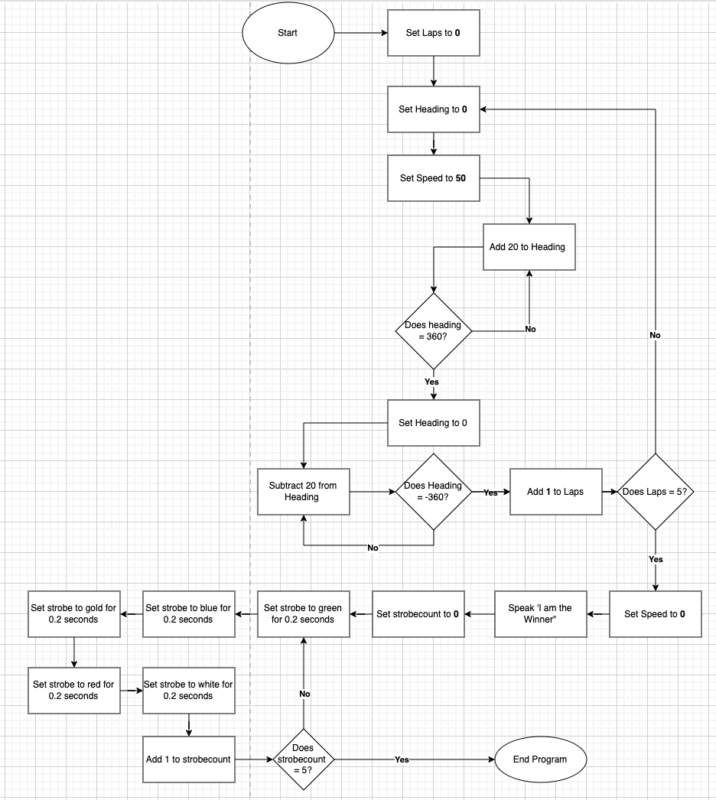

## ***Software***

* Sphero Edu program version 6.3.5
* macOS Big Sur Version 11.4 operating system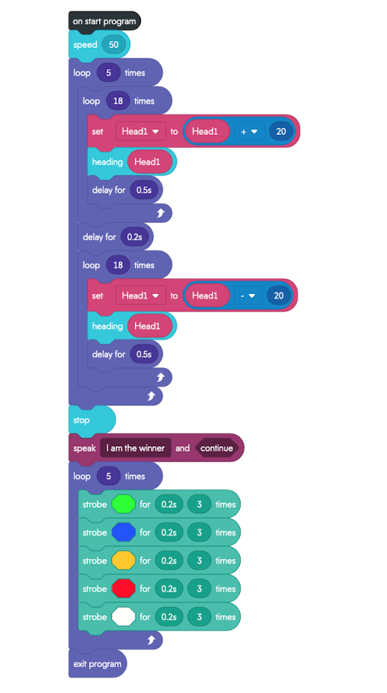

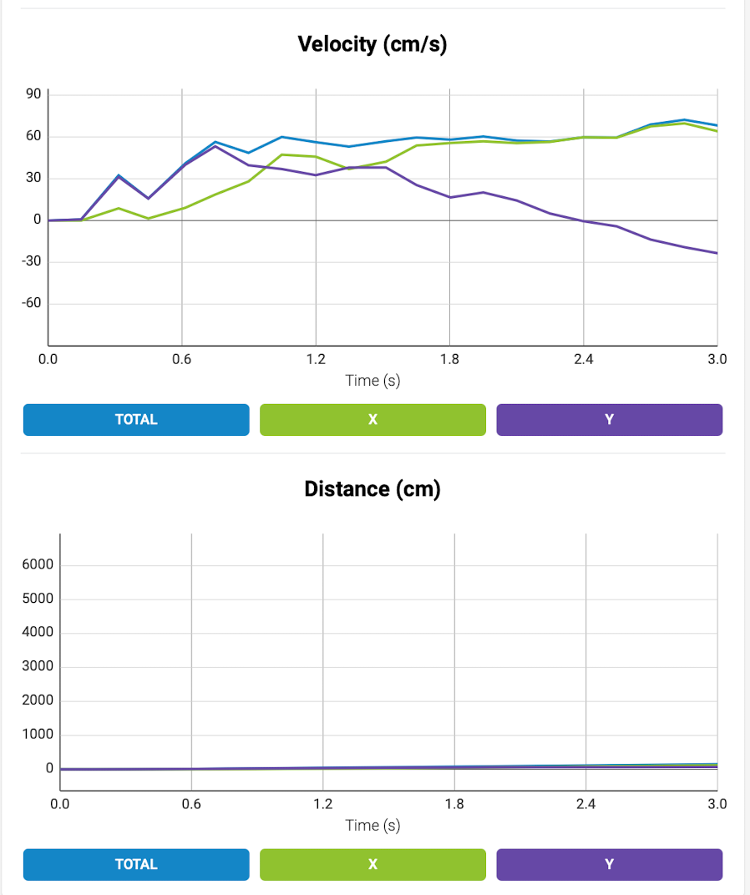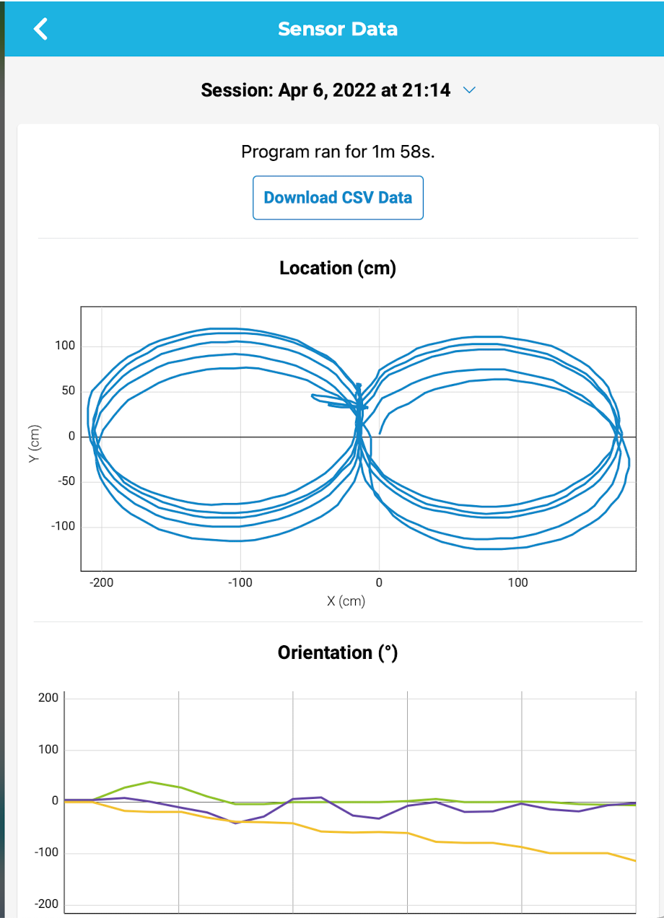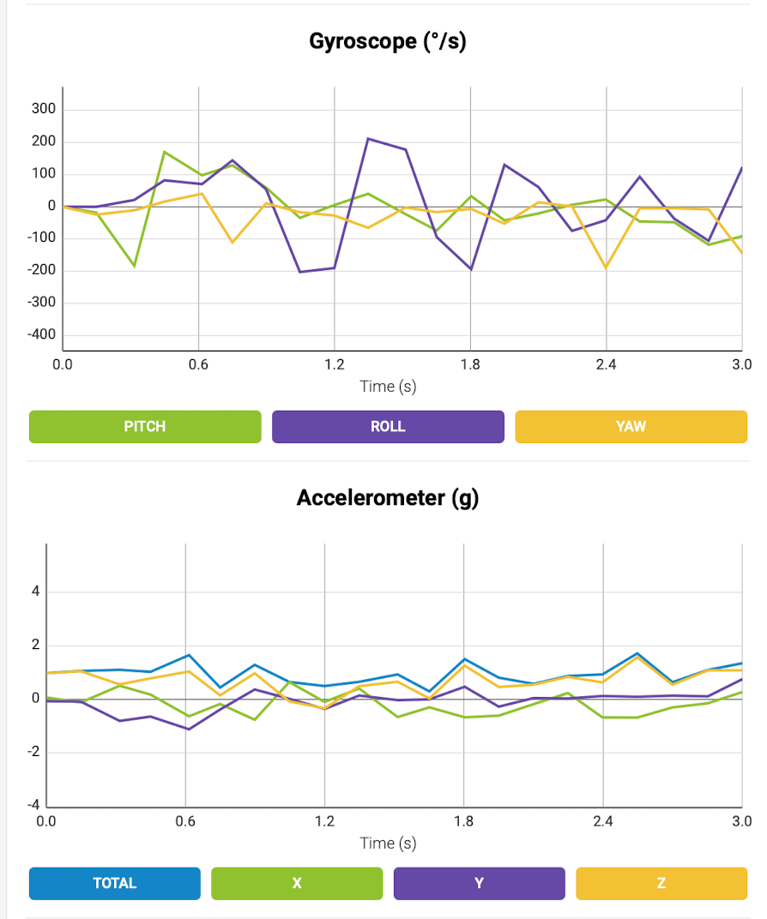

## ***Hardware***

* 2013 MacBook Pro (Late 2013)
* 2.4 GHz Dual-Core Intel Core i5 processor
* 8 GB 1600 MHz DDR3 memory
* Sphero Sprk+ robot

## ***Test Plan***

Include a test plan showing all unit tests performed for this application, Include test rational, test date, staff member, pass/fail status

| **Reason for Test Case** | **Test Date** | **Expected Output** | **Observed Output** | **Staff Name** | **Pass/Fail** |
| --- | --- | --- | --- | --- | --- |
| Gauge approximate speed and distance needed to complete first vertical section of the course | 03/30/2022 | Robot will not be successful at traveling 1st measured distance | Robot went the wrong direction (improper aim) | DV | Fail |
| Continue to gauge approximate speed and distance needed to complete first vertical section of the course | 03/30/2022 | Robot will not be successful at traveling 1st measured distance | Robot was no successful at traveling 1st measured distance (to short of distance) | DV | Fail |
| Obtain correct distance of first leg of course | 03/30/2022 | Robot will travel correct distance of first leg and pivot | Robot traveled to short of distance | DV | Fail |
| Test figure eight looping code | 03/30/2022 | Robot will follow two loop codes, with instructions to travel in a circle. The two coded loops are identical besides one having negative integers in the code where it is instructed which direction to turn. The negative integers will make the robot repeat the same actions but in a the opposite direction as the first loop,, creating a figure eight | robot correctly traveled on an unspecified figure eight | DV | Pass |
| Expand the size of the figure eight | 03/30/2022 | Robot will travel in a figure eight but make wider turn radiuses | Robot was unsuccessful - Robot made one successful circle then went in a straight line | DV | Fail |
| Expand the size of the figure eight | 03/30/2022 | Robot will travel in a figure eight but make wider turn radiuses | Robot was unsuccessful - Robot made one successful circle then traveled in a series of small circles | DV | Fail |
| Expand the size of the figure eight | 03/30/2022 | Robot will travel in a figure eight but make wider turn radiuses | Robot was unsuccessful - Robot robot only traveled in one circle and failed to change direction. However the circle was the correct size as the course | DV | Fail |
| Make 1 successful figure eight to the exact specifications as per the accuracy sprint | 03/30/2022 | Robot will complete one successful figure eight around the Accuracy course | Robot achieved the expected output | DV | Pass |
| Travel the figure eight to the exact specifications as per the accuracy sprint (5X) | 04/06/2022 | Robot will travel the figure eight outlined on the ground, for 5 laps, and finish in the center | Robot traveled the figure eight successfully for one lap but failed to repeat the course accurately the second time. Robot continued the figure eight pattern but traveled further and further away from the outline course with each lap | DV | Fail |
| Travel the figure eight to the exact specifications as per the accuracy sprint (5X) | 04/06/2022 | Robot will travel the figure eight outlined on the ground, for 5 laps, and finish in the center | Robot traveled the figure eight successfully for one lap but it was observed that it was traveling past the start point before starting the second lap of the figure eight course | DV | Fail |
| Travel the figure eight to the exact specifications as per the accuracy sprint (5X) | 04/06/2022 | Robot will travel the figure eight outlined on the ground, for 5 laps, and finish in the center | Robot traveled to small of a distance - figure eight was too small | DV | Fail |
| Travel the figure eight to the exact specifications as per the accuracy sprint (5X) | 04/06/2022 | Robot will travel the figure eight outlined on the ground, for 5 laps, and finish in the center | Robot traveled to large of a distance - robot traveled far outside of the figure eight boundary | DV | Fail |
| Travel the figure eight to the exact specifications as per the accuracy sprint (5X) | 04/06/2022 | Robot will travel the figure eight outlined on the ground, for 5 laps, and finish in the center | Robot was successful at completing 5 laps and also stayed within a reasonable distance of the tape outlined course | DV | Pass |

## ***Task List/Gantt Chart***

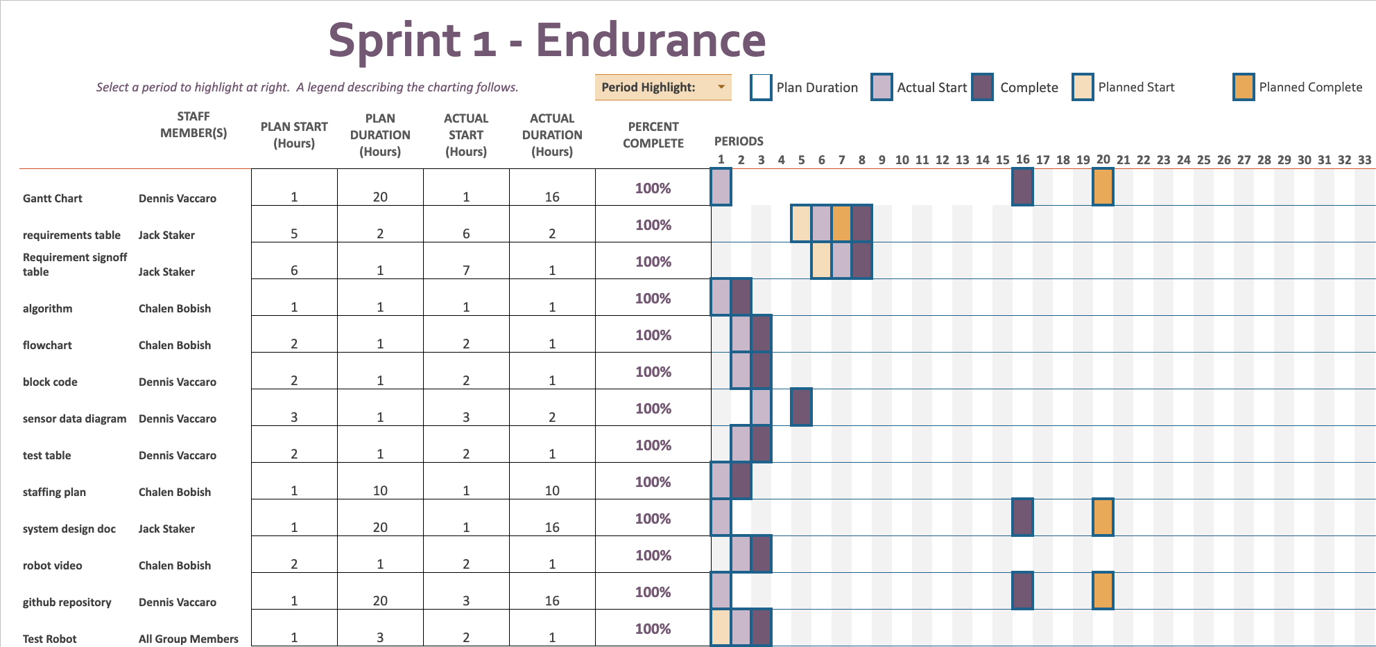

## ***Staffing Plan***

Insert a chart/table that depicts the roles and responsibilities of each team member that worked on this project

## 

| Name | Role | Responsibility | Reports To |
| --- | --- | --- | --- |
| Chalen | Data/Planning | algorithm, flowchart, and robot testing | Jack |
| Dennis | Programmer | block code, test robot, Gantt chart, Sensor data diagram maintain Github | Jack |
| Jack | Manager | System design document, robot testing | N/A |